**8. Reading the Web Temperature Text File into Dictionary and Computing Average Temperature**

**8.1 Aim**

i) Write a program to Read web temperature from data file into dictionary and computing average temperature

ii) Write a program to Access Web Pages

**8.2 Software Used**

1. Anaconda Navigator
2. Jupyter Notebook
   1. **Pre Lab Questions**

1. What is the significance of urllib package?

2. Give the syntax for importing the web page data in to python program.

3. What does the following block of code do?

import urllib.request

fhand = urllib.request.urlopen('http://data.pr4e.org/romeo.txt')

**for** line **in** fhand:

print(line.decode().strip())

A. It creates a file named 'romeo.txt' in 'data.pr4e.org'

B. It finds the urls linked to 'data.pr4e.org' and prints it.

C. It opens a file named 'http://data.pr4e.org/romeo.txt' in local storage  
D. It prints the contents of 'romeo.txt' after retrieving it from 'data.pr4e.org'

* 1. **Program**

import urllib

import re

response = urllib.request.urlopen("http://weather.yahoo.com/forecast/NOXX0029_c.html")

html = response.read()

d={}

s=[]

for i in html:

d["Sunnyside"]=i

s.append(i)

print("Average=")

print(sum(s)/len(s))

**Output Response:**

Average=83.45694053007217

**Output:**

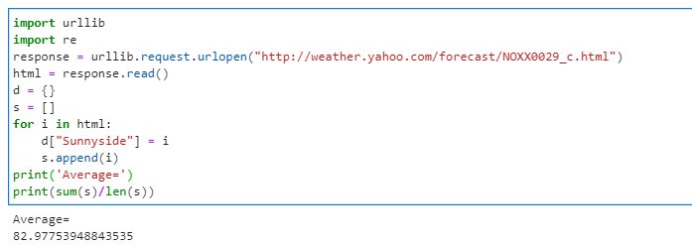

**ii) Reading HTML file Using urllib**

**PROGRAM:**

import urllib

import re

response = urllib.request.urlopen("http://weather.yahoo.com/forecast/NOXX0029_c.html")

html = response.read()

print(html)

**OUTPUT:**

b'<!DOCTYPE html><html id="atomic" class="NoJs desktop" lang="en-US"><head prefix="og: [http://ogp.me/ns#"><script>window.performance](http://ogp.me/ns#%22%3E%3Cscript%3Ewindow.performance)&& window.performance.mark && window.performance.mark(\'PageStart\');</script><meta charset="utf-8"/><meta http-equiv="x-dns-prefetch-control" content="on"/><meta name="apple-itunes-app" content="app-id=628677149"/><meta name="render-optimize-policy" content="first-screen-advance;enable"/><meta name="referrer" content="unsafe-url"/><meta name="oath:guce:consent-host" content="guce.yahoo.com"/><meta name="twitter:description" content="View the latest weather forecasts, maps, news and alerts on Yahoo Weather. Find local weather forecasts for Sunnyvale, United States throughout the world"/><meta name="twitter:title" content="Sunnyvale, United States - Weather Forecasts | Maps | News - Yahoo Weather"/><meta name="description" content="View the latest weather forecasts, maps, news and alerts on Yahoo Weather. Find local weather forecasts for Sunnyvale, United States throughout the world"/><meta name="keywords" content="weather forecasts, weather reports, weather maps, Sunnyvale, United States weather forecast, worldwide weather forecast, local weather forecast, 5 day forecasts, 10 day forecasts, news, weather alerts, yahoo weather, yahoo"/><meta property="al:android:package" content="com.yahoo.mobile.client.android.weather"/><meta property="og:description" content="View the latest weather forecasts, maps, news and alerts on Yahoo Weather. Find local weather forecasts for Sunnyvale, United States throughout the world"/

**Output:**

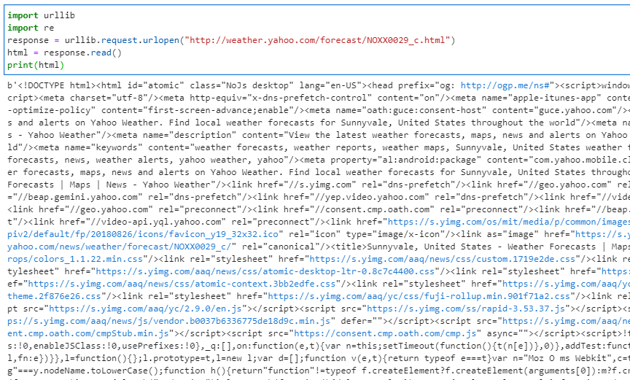

* 1. **Post Lab Questions**

1. How to get the response of the average temperature in the form of html. Give a sample.

**8.6 Result**

Write a program to Read web temperature from data file into dictionary, computing average temperature and also write a program to Access Web Pages